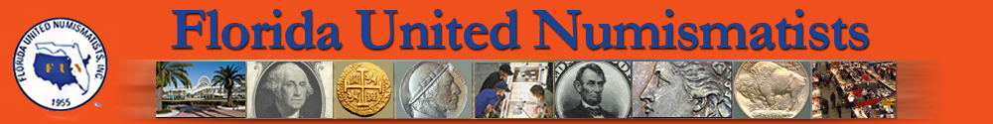
Nominate A Numismatic Ambassador
Nominee Name: Please Detail the qualities you have observed in the nominee
_____________________________________________ that qualify him or her to be a Numismatic Ambassador. Be
Nominee Address: as detailed as possible. Please attach additional sheets as
_____________________________________________ necessary.
_____________________________________________ __________________________________________________
Nominee Email: __________________________________________________
_____________________________________________ __________________________________________________
Nominee Telephone Number: __________________________________________________
_____________________________________________ __________________________________________________
National, State and Local organization the nominee __________________________________________________
Is a member of and offices or positions held? __________________________________________________
_____________________________________________ __________________________________________________
_____________________________________________ __________________________________________________
_____________________________________________ __________________________________________________
_____________________________________________ __________________________________________________
_____________________________________________ __________________________________________________
_____________________________________________ __________________________________________________
_____________________________________________ __________________________________________________
_____________________________________________ __________________________________________________
__________________________________________________
Is the nominee active in Young Numismatists, National __________________________________________________
Coin Week, teaching classes? Specify: If you are unable to provide the biographical details requested
_____________________________________________ and are aware of someone we might contact for additional
_____________________________________________ information, please indicate below:
_____________________________________________ Contact Name: ____________________________________
_____________________________________________ Contact Address: ___________________________________
_____________________________________________ _________________________________________________
_____________________________________________ Contact Phone Number: _____________________________
_____________________________________________ Nomination Submitted by: ___________________________
_____________________________________________ _________________________________________________
What is the nominee’s major collecting interests? Address: __________________________________________
_____________________________________________ __________________________________________________
_____________________________________________ Telephone Number: _________________________________
_____________________________________________ E-Mail: ____________________________________________
_____________________________________________
2023/24 Nominations are Due September 1, 2023
Send the completed form to:
Attention: Tony Swicer
FUN Administrator Numismatic Ambassador Award
P.O. Box 5823, Lake Worth, FL 33466
E-mail: swicer@comcast.net | Phone: (561) 964–7236

